Blakedown and Hagley Tennis Club

Coaching Report AGM November 2020

Introduction

I2c have been delivering coaching at the club for over 12 months having launched the programme in October 2020.

Our programme is lead by coach Chris Summerbell a level 3 coach with extensive experience of working in schools. The programme consists of sessions for different age groups and adult beginner coaching groups, taking place every Wednesday.

Blakedown and Hagley Tennis Club comes under the remit of Area Manager Tina Manning. Tina is a Level 3 coach, she is also She Rallies Ambassador for Hereford and Worcester and chairs the County Junior Development Committee.

We had an annual plan in place for 2020 which included a programme of activities and initiatives throughout the year eg. Open day, working with the local schools in Blakedown and Hagley, Tennis for Kids sessions.

Unfortunately, many of the initiatives have been postponed due to Covid-19.

The positive news is that we were able to resume tennis coaching in June following lockdown and have seen a growing interest in the club and coaching programme.

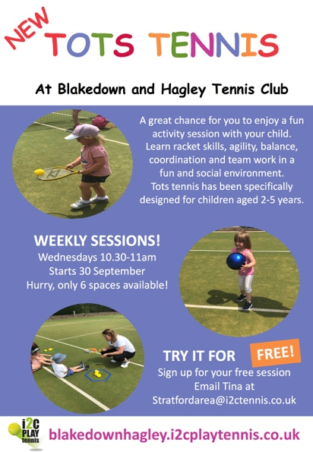
In September we launched a range of new sessions: Tots tennis, cardio, Tennis for Kids and Try Tennis for Adults – please see marketing below:

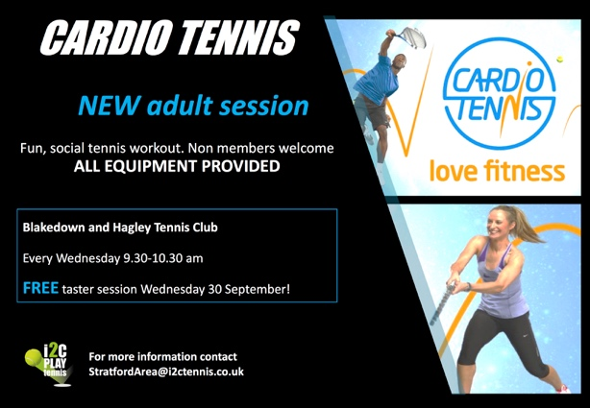

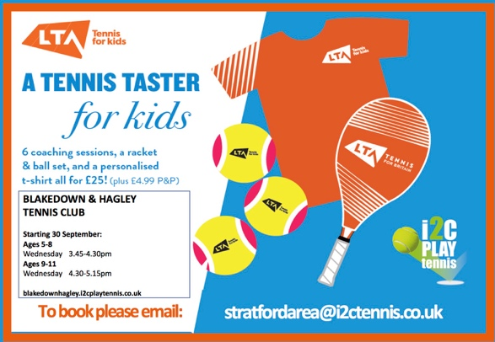

The Tennis for Kids course has been a resounding success with over 15 children signing up to do the 6 week course! Children will be offered an ongoing place on the programme once the course finishes.

Tots tennis has also gone down well with 4 families having just signed up to ongoing sessions.

Cardio and Try Tennis has not created much interest at this stage but we’ll promote again after ½ term.

Current Coaching Programme

10.30 – 11am Parent and tots (4)
2-3pm Adult beginners (2)
3.45-4.30pm Tennis for kids age 5-8 (11)
4.30-5.15pm Tennis for kids age 8-11 (5)
5.15-6.15pm Mini hitters age 12+ (4)
6.30-7.30pm Adult coaching (6)

Plans for 2021

Many of the plans for 2020 will be reintroduced for 2021.

We will continue to grow the programme by:
- Growing our existing sessions
- Offering more sessions through the day eg. Cardio, Adult daytime/term time sessions
- Setting up taster courses – Tennis for Kids and Try Tennis for adults and teens
- Linking with the local schools
- Open day
- Review the option of offering holiday camps in the main holidays
- Using effective marketing material and platforms to promote the club and programme

We would be very open to suggestions of other sessions the club would like to introduce to support existing members and their families.

I2C would like to thank the club for their support in our first year and look forward to building the coaching programme and members of the club further!

Tina Manning

Area Manager

