Hook Norton Tennis Club Newsletter April 2021
As light hopefully appears at the end of the long Covid tunnel, the theme of this newsletter has to be the word “new” so let’s start by taking a look at the new and emerging talent that is beginning, finally, to challenge the reign of the fabled threesome who have dominated for so long in men’s tennis. My top three picks are Daniil Medvedev who is appearing regularly in finals thanks to his recent amazing unbeaten run, Jannick Sinner who is still (just) a teenager but who already has some notable scalps to his credit and Stefanos Tsisipas who has already beaten the top three. I still wouldn’t bet against Nadal winning the French again or Djokovic the US but they can’t feel quite as confident as they might have done just a year or two ago. As a diehard Roger fan, sadly I think that his time is probably up. Then in the ladies, Naomi Osaka must be favourite now to win slams over Serena Williams and Simona Halep but she too will be keeping her eye on the young French champion Iga Swiatek, who is barely out of school.
And here in Hook Norton welcome (back) to both new and returning members. It is especially good to see any new members who may have taken up tennis over the past year as a way to exercise and who have got hooked on the sport! The Covid rules, which were emailed to all members recently, are also to be found if you scroll down the website home page - these rules must be strictly observed and you must book to play. Don’t forget to send a text to the WhatsApp group if you want to attend a club session. Text Stuart on 07810 155973 if you want to be added into the group. You can read all the rules and find the booking link here
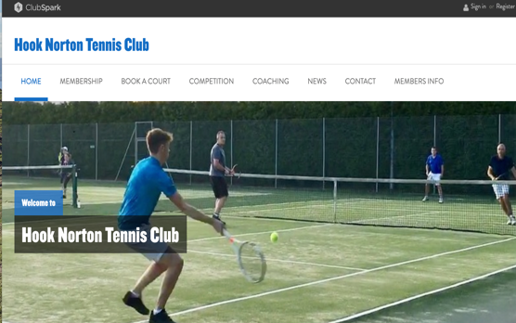
https://clubspark.lta.org.uk/HookNortonTennisClub
Another “new” for the club is now operational. The new website is now being run through the LTA system ClubSpark which also organizes membership/renewals, fee payments and court bookings. You should have received an email from Kate Hopkins, our new membership secretary, asking you to register on ClubSpark and to click through to set up/renew your membership and pay your fees. Please contact Kate ( hntcmembershipsecretary@gmail.com ) if you haven’t heard from her, or if you have problems with ClubSpark. You also need your ClubSpark registration to book a court.
So, lots of new things to take on board but of course some of the old favourites are still going strong. Firstly, we hope to run a fun mixed tournament on Saturday 8th May at 1:30pm. All abilities will be catered for and we’ll put people together to be as fair as possible so you don’t need to worry about finding a partner. The cost to enter is £3 and everyone will play 6 x 15 minute rounds. If you’d like to join in, please email Hopkins-stuart@hotmail.co.uk. Numbers are limited so it’s first come first served with the bookings.
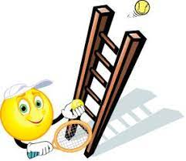
Secondly there will be a singles ladder as in previous seasons. You organise your own matches and progress up the ladder if you beat people on the rungs above. Alex Hollingdale is organising this so contact him on alexhollingdale@gmail.com if you’d like to take part.
Thirdly the matches in the Banbury League will starting again in mid-April. The winter league has been cancelled as not many matches had been played and it would have been too complicated to reschedule them all. So it was decided at the Banbury League AGM to start afresh with the new summer season. Contact Stuart on Hopkins-stuart@hotmail.co.uk if you’d like to play in a team.
Last but not least the AGM will take place on Tues 22nd June at 7pm in the pavilion. It is usually a short meeting but it is an important forum for discussion so please come along and support your committee. If you are interested in joining the committee then please get in touch with Renato. Thank you to all our committee members and volunteers who put in so much hard work on behalf of all the members, especially during this last year of unprecedented circumstances.

