LUDL0W CASTLE TENNIS CLUB
MINUTES OF THE MEETING HELD ON 21st NOVEMBER 2019 AT 7.00PM
AT FEATHERS HOTEL LUDLOW
PRESENT
Jenny Nicol (Chairperson) JN, Seabury Salmon (Vice Chairperson) SS,
Jane Hulley Jane, Linda McMahon LMC, Alastair Flint AF, Marcus Bassett MB,
Julie Humble Julie, Richard Tennant RT, Josh Price JP, Jim Hill Jim
1.Apologies
Apologies were received from Les Martin, Angela Martin, Laura Johnston, Di Kemp.
2. Matters Arising
No. | Action From Previous Meeting | Responsibility | ?Completed
1 | Club Kit | JN | AM completed
2 | Coaching Hours | SS/JN | Done
3 | Plaques for Benches | LJM | Done
4 | Publicity for the Club Championships | SS | Done
5 | Refreshments for the Club Championships | AM | Done

3. Chairman’s Report
JN apologized for not sending out minutes of last meeting on time.
JN began the meeting by outlining the focus of this evening’s meeting was to discuss in detail the current on-going flooding issues at Ludlow Castle Tennis Club.
As you can imagine it’s been a baptism of fire over last month, but the upside is that I have accumulated a lot of knowledge about both the courts and the Club site very quickly. I had hoped to send out information before tonight but some of the information only came in late yesterday so haven’t had time. However, we do not have to make any decisions tonight. The fact that we had 2 very effective clean up days after each of the floods means that we have 4 courts in action and that buys us some time and we can continue to review the options.
I think climate change is real and here to stay for the foreseeable future, so we need to think about both long- and short-term options. The due diligence that Seabury, Ken and I have done over the last 4 weeks is as follows: -
Re site as a whole: Conversations with National Flood Forum, Friends of Corve and Teme, Terry Jackson
Re Courts: Tennis Shropshire, NFU (insurance), 5 court maintenance companies plus Platt who laid the courts (more later), Lon Teo and Bob Purcell have all been consulted.
Long Term Options
- Raise the level of the courts – non-starter as too high and unlikely to get permission from Environment Agency and unpopular with neighbours
- Move location of Club. We are in a flood plain which isn’t ideal. We have considered the Burway site but after considerable thought I now don’t think we should pursue this option for several reasons – i)cost of the exercise would be beyond our means even with potential grants and loans.– relaying courts, power issues, club house, ii)we don’t know at this time whether we could get the land from Earl of Plymouth, iii) I don’t think time is right in terms of where we are in the life cycle of the courts. Still got quite a few years life left, iv) the effectiveness of the court clean-up suggests to me that we can, with the right tools, cope with the effects of flooding at least for now. Ken and Bob P concur. We just don’t know what will happen in the future – we can only monitor it armed with all the information we have gathered and continue to improve our preparedness and response.
My long-term recommendation to the Committee is therefore, now, to stay for the foreseeable future.
Short Term Options
Clay courts: -
Even before floods we had noticed that drainage was an issue and in fact this sort of court surface would expect to be rejuvenated (old infill out and replaced with new) after about 5/6 years.

Tests have revealed that underlying Tarmac is free draining

Waterlogging is due to ceramic coating which has delaminated from the sand grains it originally coated and formed a thin but impermeable layer at the bottom of the carpet pile.

The monofilament carpet pile is in very good condition, no great wear.
Solution advised by all the companies we have approached is rejuvenation i.e. air blasting all the old sand, ceramic and silt out, collecting and disposing of it (in the car park) and replacing it with British sand that is heat treated in Stoke rather than ceramic coated in Belgium.

Comparison of Quotes
2 Courts
 |  | Total (incl VAT) | Sand
Platt | Chester |  | Sidec or Dorfner coated Belgium, Germany
Tennis Ct Surface Solutions | Colchester | 8,880.00 | Silica kiln dried
Euroclay | Southam | 11,520.00 | Garside 2EW - UK burnt
Replay | Notts | 14,994.00 | Garside
Fosse | Leicester | 22,344.00 | Garside 2EW - UK burnt
Technical Services Ltd | Leicester

Timing
Consensus, confirmed by Platt, is that a dry spell in Spring would be preferable to now. Problem is not taking sand out but putting new infill into a wet carpet. Also spending significant sum at a time of high risk of repeat flooding would not seem sensible. Finally, long lead time might result in more competitive price.
Green courts: Have coped with floods well – cleaned up and don’t appear slippy. Need to treat moss and algae.
Recommend wait till Spring and then “revitalise” – infill lifted and filtered and then put back. Work should cost about £700 for a day’s work on 3 green courts.
Other considerations
Insurance: Investigate Flash Flood – a premium of £1,112 p.a would secure a payout of £30,000 if water level reached trigger depth of 0.3m. There would be additional cost of £120 p.a. for sensor license.
Maintenance: We need to assess the cost and viability of buying additional equipment and doing more maintenance ourselves vs entering a maintenance contract with a professional company.
Julie suggested that the current silt protectors were not tall enough. JN agreed it should be considered, JN also considered the use of large sponge rollers to soak up any remaining surface water, JN to research further.
A VOTE WAS TAKEN REGARDING THE TIMING OF THE WORK REQUIRED FOR THE CLAY COURTS IT WAS PROPOSED THAT ALL BIG WORKS SHOULD NOT COMMENCE UNTIL SPRING 2020. A SHOW OF HANDS WAS UNANIMOUS DECISION 9/9, THEREFORE PROPOSAL CARRIED
4. OTHER BUSINESS MATTERS DISCUSSED
i) Subscription rates: Couples
JN Proposed that due to the cost of the rejuvenation work and the fact that the Club is sited on a flood plain with the attendant higher maintenance costs it may be prudent at this stage to discuss increasing Subs. JN stated that she had already discussed this informally with several members and the feedback indicated a general acceptance of the need for an increase in subs. Julie felt that an additional increase in subs over and above the £5 increase approved at the AGM in October would be unfair. It would be better to increase subs again next year. Jane and AF agreed.
JN further proposed that we consider no longer offering the discounted “Couples” subscription rate. This would generate £800.00 additional annual income. LMC and Julie agreed with the proposal but there was not a majority in favour. JP stated that the couple’s subscription rate was a great selling point for the club. In discussions with other clubs the consensus was that a multi-level subscription offering was attractive to existing members and prospective new members. SS also commented that the Couples subscription was particularly attractive to couples where one partner played frequently and the other less so. If both had to pay full adult membership, then one might choose not to renew.
VOTE WAS TAKEN ON WHETHER TO WITHDRAW COUPLES SUBSCRIPTION RATE. 2 IN FAVOUR, 7 AGAINST. THEREFORE, NO CHANGE IN COUPLES SUBS,
ii) Early Subscription Payment Discount
JN stated that having got approval from members to accept a £5 increase in subscriptions it didn’t make sense to then continue to offer the £5.00 discount for early (on time) payment. Jane stated that it was introduced to encourage people to pay before closing date and to encourage members to attend subs night and enter the Wimbledon draw. However, most people now pay online through Club spark which has improved the timeliness of payments. Also, some held the opinion that we did not need to offer a financial incentive for people to enter the Wimbledon draw.
VOTE WAS TAKEN RE THE PROPOSAL TO NO LONGER OFFER THE £5.00 EARLY PAYMENT DISCOUNT AS OF 2020. SHOW OF HANDS UNANIMOUS DECISION 9/9 CARRIED.
5. TREASURER’S REPORT
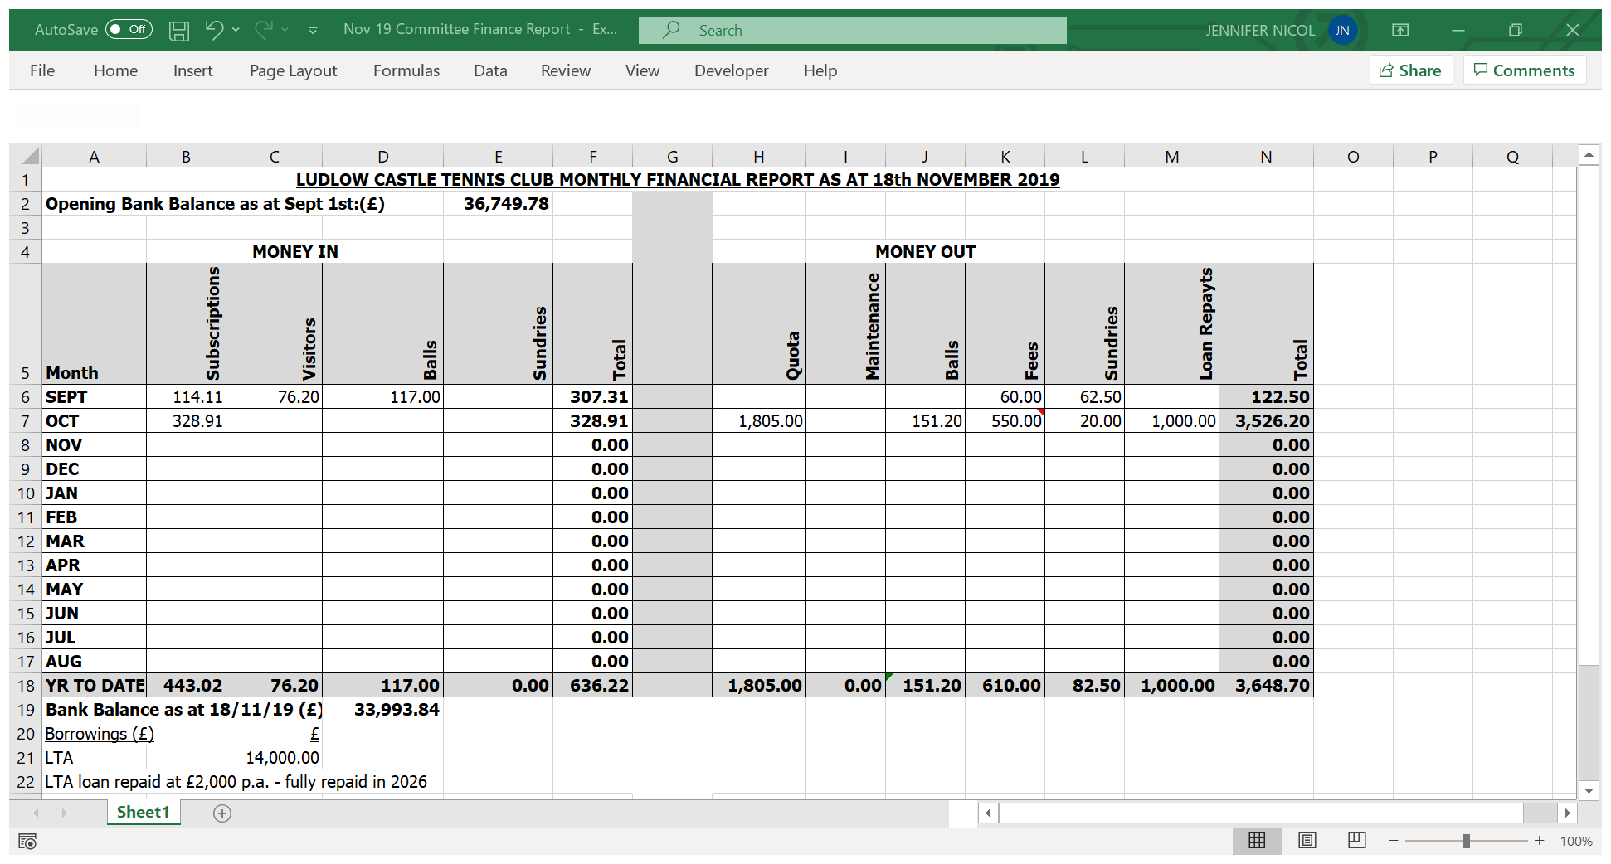

6. MEMBERSHIP REPORT JH
Jane advised no major changes since the AGM

Membership listed on Club spark as at 20th Nov 2019
 | Total adults (all categories) |  |  | 188
 | Total juniors (all categories) |  |  | 95
 | Total young members |  |  | 11
 | Total of all club members |  |  | 294
MEMBERSHIP PACKAGES |  | TOTALS | M |  | F | NOTES
Adult Singles |  | 108 | 70 |  | 38
Adult Single Country |  | 5 | 4 |  | 1
Couples |  | 40 | 20 |  | 20
Family Members - Adults |  | 16 | 8 |  | 8
Family Country Members |  | 2 | 1 |  | 1
Honorary Members |  | 7 | 5 |  | 2 | 7 only listed on Clubspark (10 in total)
Coaching Members |  | 3 | 0 |  | 3
Juniors |  | 47 | 34 |  | 13 | 7 are listed under Families in Clubspark
Mini Juniors |  | 48 | 37 |  | 11 | 8 listed under Families in Clubspark
Parent Members |  | 7 | 3 |  | 4
Young Members |  | 11 | 9 |  | 2
Total of all members |  | 294 | 191 |  | 103
Revenue taken on Clubspark as at 20th Nov 2019 = £23,654.38
Membership listed on Clubspark as at 12th Oct 2019 - AGM
 | Total adults (all categories) |  |  | 187
 | Total juniors (all categories) |  |  | 93
 | Total young members |  |  | 11
 | Total of all club members |  |  | 291
MEMBERSHIP PACKAGES |  | TOTALS | M |  | F | NOTES
Adult Singles |  | 107 | 70 |  | 37 | 11 more than 2018
Adult Single Country |  | 5 | 4 |  | 1
Couples |  | 40 | 20 |  | 20 | 4 more than in 2018
Family Members - Adults |  | 16 | 8 |  | 8 | 2 less family adults than 2018
Family Country Members Adults |  | 2 | 1 |  | 1
Honorary Members |  | 7 | 5 |  | 2 | 7 only listed on Clubspark (10 in total)
Coaching Members |  | 3 | 0 |  | 3 | 1 less than 2018
Juniors |  | 46 | 33 |  | 13 | 7 are listed under Families in Clubspark – 19 less than 2018
Mini Juniors |  | 47 | 37 |  | 10 | 8 listed under Families in Clubspark- 12 less than 2018
Parent Members |  | 7 | 3 |  | 4 | 2 less than 2018
Young Members |  | 11 | 9 |  | 2 | 2 more than 2018
Total of all members |  | 291 | 190 |  | 101 | 18 less than 2018
Revenue taken on Clubspark as at 9.10.19 = £23,474.38

Jane reminded the coaching team that she was waiting for D.O.B. for Olly Farr. JP and RT to chase and get back to her with information needed.
7. SOCIAL TENNIS
AF reported Saturday afternoon social tennis was still poorly attended. Only 4 members had expressed an interest in playing regularly. Emails have been sent to drum up some interest but to no avail and therefore we need to consider whether to continue this session.
An alternative is to reinstate the Sunday afternoon session. LMC stated there may be clashes with external matches. AF queried whether to reinstate the Wednesday evening session which used to be popular with a barbecue organized at the end every month. Julie suggested that the once a month tournament had been successful in the past. AF suggested that better (more pro-active) organization of social sessions might improve attendance. It was suggested that it might be helpful to send out a Clubspark message to all members asking them to provide ideas for social activities. At the same time, we should consider creating a pool of people (not necessarily Committee members) who would be willing to act as organisers. JN thanked AF for all his patience and hard work in trying to keep Saturdays going.
8. COACHING REPORT
JP Reported that the new court scheduling was working well. No other issues;
JP also reported that Inspire to Coach had recently employed a maintenance consultant who had worked for LTA for many years. His main role was to advise clubs on courts equipment etc. and he may be able to advise on the flooding issues. Josh to arrange meeting on the Tuesday the following week
9. SAFEGUARDING
MB stated he had updated his DBS as required, no other issues to discuss
10. TEAM CAPTAINS REPORT
Julie stated that the Ladies teams and Captains for the upcoming season had been organized with Chris Hood assisting with selection. Rosie Connolly is the first team captain and Ang Martin second team captain. Coaching dates had been set but due to the weather and flooding issues they had to be cancelled so only one successfully took place with RT. Ladies winter league had started and results had been ladies first team have one losing draw and one win, ladies second team one winning draw.
Furthermore, two success stories from the Shropshire summer leagues - Ludlow Castle first team mixed won Div 4 and the second team came second. Therefore, both teams were promoted to Div 3. Also, the Men’s first team won Div 2 so were promoted to Div 1
11. ANY OTHER BUSINESS
AF Stated that on behalf of the committee he would like to thank Jenny and the flooding sub-committee for all the hard work they have put in over the past several weeks. Thus, ensuring that we all have a good understanding of our current position in relation the major flooding issues at our club, and the considerations needed to be made by the Committee going forward, it has been greatly appreciated.
The Committee was informed that inscribed plaques will be put on the back of the new benches financed from the money brought over from Burway. These will be sourced by Les.
JN reported she is waiting for two more quotes and will report back to committee when they are received.
Summary of Action Points

No. | Action | Responsibility | ?Completed
1 | Attend to moss and algae | KS | Done – although further action needed
2 | Insurance | JN | In process
3 | Maintenance equipment | JN/SS/KS/LT | Discussions ongoing
4 | Silt Fence to be raised | JN/SS/KS/LT | Discussions ongoing
5 | Contact membership re social activities at the Club | AF | Done
6 | Create pool of event organisers | AF/JN | Attempted but not successful to date

NEXT MEETING :
Originally scheduled 13th Feb. at The Feathers
NOW RESCHEDULED TO THURSDAY 6TH FEBRUARY 7PM AT ROSE AND CROWN

Signed;

Jenny Nicol
Chair

