Members Handbook

Welcome
This booklet is to provide new members with information about the club, so that you can enjoy the club, its activities and facilities.
If you have any questions, please use the contact page to contact a committee member or visit our website at :
https://clubspark.lta.org.uk/ marketharboroughlawntennisclub

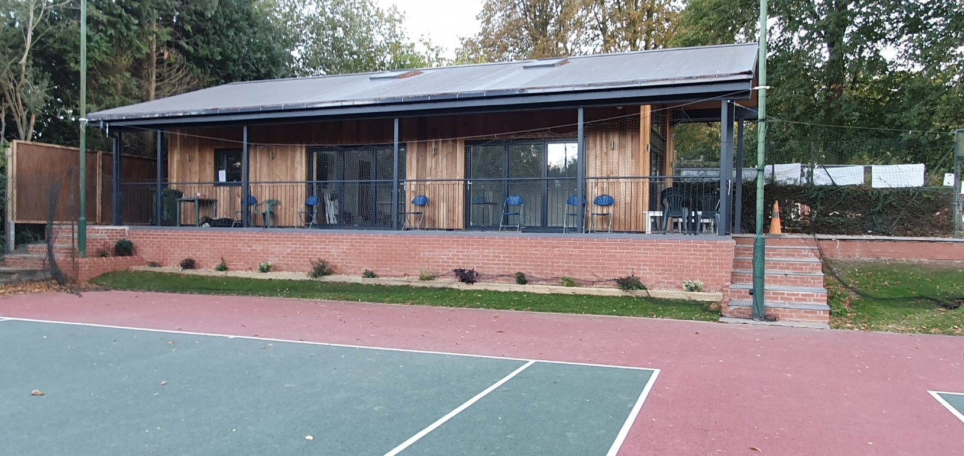

Contents Coaching Social Tennis
Competitive Tennis Clubspark Contacts
Useful Information

Coaching

Junior Coaching

Coaching courses are available for juniors of any ability from the age of 2½ years. During the spring, summer and autumn there are coaching sessions for all age groups and during the winter we run courses at indoor venues.
To enrol or for enquiries please contact our head coach Phil Harris (Tel: 07740348335, coach@tennisteacher.co.uk).

Adult Coaching
We also offer a wide range of adult coaching all year round and for all abilities.
For more information either check our website or contact our head coach Phil Harris (Tel: 07740348335, coach@tennisteacher.co.uk).

Please check our website for current coaching sessions https://clubspark.lta.org.uk/MarketHarboroughLawnTennisClub/ Coaching

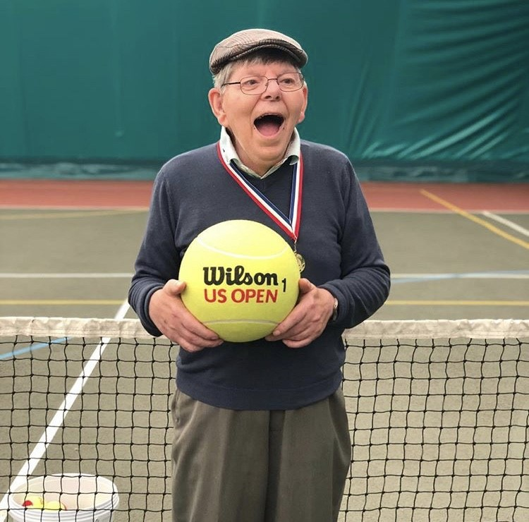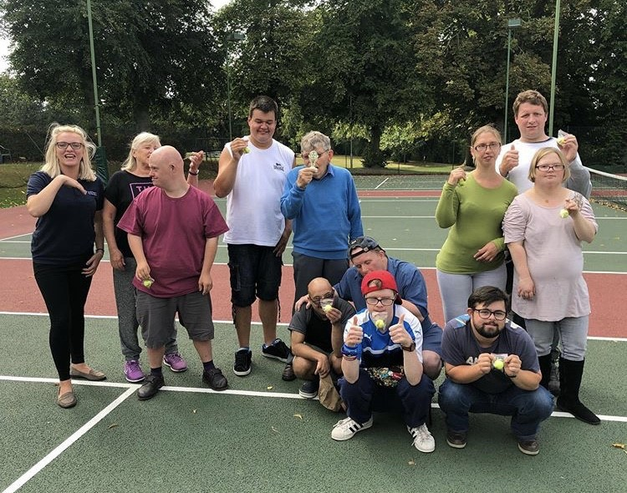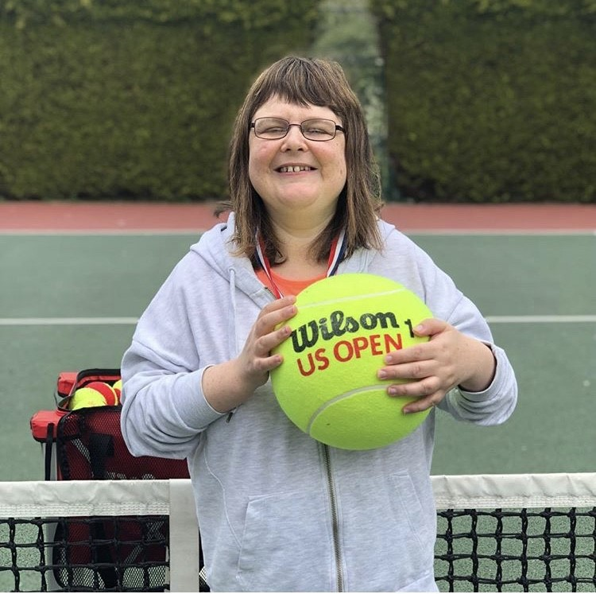Inclusive Coaching
Our thanks goes out to all the volunteers who give their time each week. At present coaching happens on Wednesdays with Phil the coach leading 2 hourly sessions. The first session is for adults from Freedom Support in the town and the second for juniors from Birkett House school in Wigston.
Over time we have seen basic skills improving with all those who participate. The coach, volunteers and participants have all learned from the experience in a very positive way. If you would like to help , contact either Phil the coach or Lesley the club chair.

Also we must thank all those organisa- tions who have sponsored us so far and allow this to happen:
Harborough District Council Freedom Support, Strangward Trust
Leicestershire and Rutland Community Awards-Maud Elkingtom Trust

Anyone who would like to donate towards this coaching please contact Bob Holland our treasurer

Social Tennis
Thursday evenings from 7pm are our main adult club evening where members of varying standard all mix in. Throughout the summer there are BBQ`s and themed food evenings all free of charge.
Tuesday evenings from 7pm are for those who are less confident or want a gentler game and there is a social mix in on a Monday from 10-12noon.

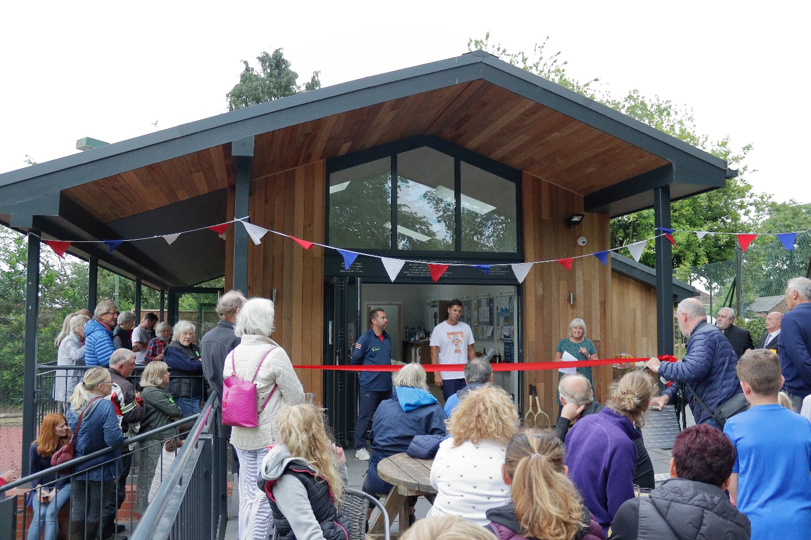

We also currently offer cardio tennis twice a week. Cardio Tennis is a fun, sociable group fitness class set on a tennis court and open to people of all ages and abilities. If you want to find a healthy, new way to get in shape and to burn calories, then why not give this a go!

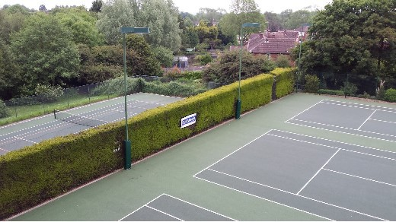Competitive Tennis

Adult and Junior competitive tennis
In the summer we have several mens, ladies and mixed teams that play their matches between May and July.
We have a number of Vets teams (ladies 40+ and men 45+)who play their matches between June and August,
We also run teams in the winter leagues that play from September to December
We run many junior teams in the summer and have team coaching sessions for them.
Please get in touch with Phil if your child would like to play in matches.

Club Tournaments
We play a number of social tournaments throughout the year. Details of these are put out on social media and emailed out to club mem- bers. We also end the summer season with adult and junior club championships. Members are encouraged to sign up for singles and doubles with matches being played throughout July and August with all finals being played on a Sunday in September.

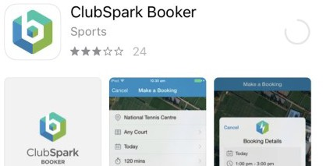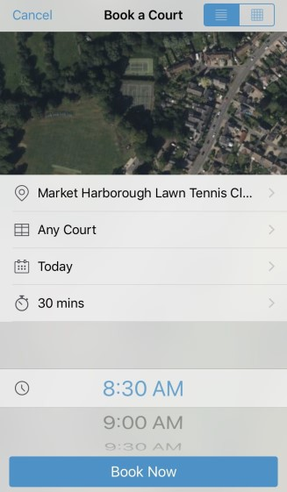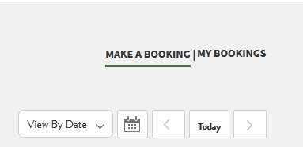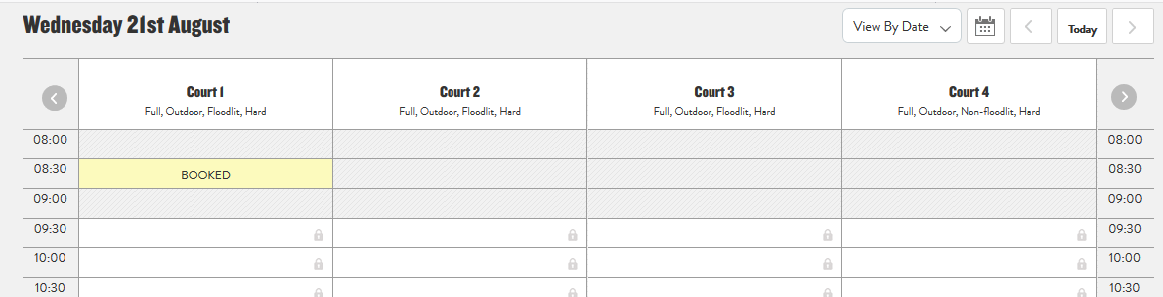ClubSpark
How to book a court
To book courts you need to be registered on the ClubSpark system.

ClubSpark Booker app

- Download the ClubSpark Booker app from the app store
- Once in the app either sign up or sign in using your previous ClubSpark details
- At the bottom of the screen will be the option to book a court—click on this

- Select the court, day and time you want to book the court and for how long and then press ‘Book Now’ at the bottom (please note only availa- ble courts will show)
- Your booking will now show up on the homepage of the app.

Online via our website—you will need to be signed in to ClubSpark to make a booking

- Go to https://clubspark.lta.org.uk/MarketHarboroughLawnTennisClub/Booking/ BookByDate#?date=2019-08-21&role=guest

- Once signed in look in the right hand corner and click on ‘Make a booking’

- You should then be able to make a booking by clicking on the time slot you want (please make sure it’s under the correct court)

Any questions please contact our membership secretary Sarah Parr

Safeguarding

Market Harborough Lawn Tennis Club (MHLTC) is committed to prioritising the well-being of all children and adults at risk,
promoting safeguarding in our club at all times, including all
programmes and events we run.
Full details of our safeguarding policy can be found on our web- site (https://clubspark.lta.org.uk/ marketharboroughlawntennisclub) under the POLICIES
tab. In addition, further information on Safeguarding will be on displayed in the clubhouse.

Useful Information

Court bookings
If you would like to book a court for use please do so via our website https://clubspark.lta.org.uk/MarketHarboroughLawnTennisClub

Visitors
Visitors are welcome with a member up to 3 sessions a year. Mem- bers should sign the book in the clubhouse and pay £5 per session

Dress
All members are requested to wear non-marking tennis shoes and appropriate tennis clothing whilst playing on the courts

Floodlights
Floodlights are free to use for all club members. Please make sure that they are turned off after use.

Tennis balls
Used match balls are stored in the Clubhouse for members use. New balls can be purchased from Janice Glover (07738858000 or janice- glover45@hotmail.co.uk)

Wimbledon Opt in
We would encourage all members to join the LTA by logging on to www.lta.org.uk/Members/Join/ and obtaining a BTM number. This en- ables you to opt in for the Wimbledon ballot and helps the allocation of tickets to the club.

@Harb_tennis

Market Harborough Lawn Tennis Club

Contacts

CHAIRPERSON
Lesley Paris 07736678575
lesley.paris@ntlworld.com

HEAD COACH
Phil Harris 07740348335
coach@tennisteacher.co.uk

MATCH SECRETARY
Carol Krone
07792173810
c.krone@ntlworld.com

MEMBERSHIP SECRETARY
Sarah Parr 07971525265
sarahparr21@icloud.com

TREASURER
Bob Holland bobholland@me.com

WELFARE OFFICER
Janice Glover
07738858000
janice- glover45@hotmail.co.uk)

