How to obtain a BTM (British Tennis Membership) Number

<https://www.lta.org.uk>



Click on JOIN (top right)

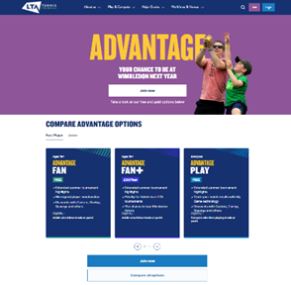

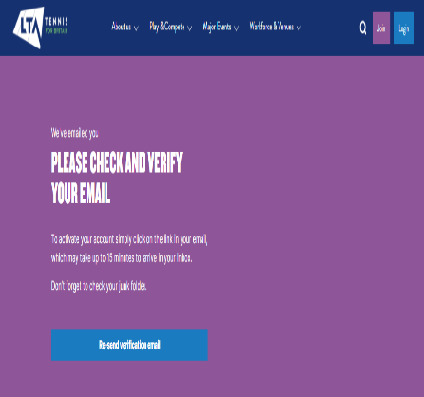

Go to your inbox of e-mails, if it has not arrived check the junk/spam folder.

2 emails –

Email 1 to verify your email address – click on verify email address

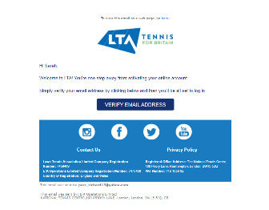

Email 2 –



Your BTM number

Please send to

Sarahparr21@gmail.com

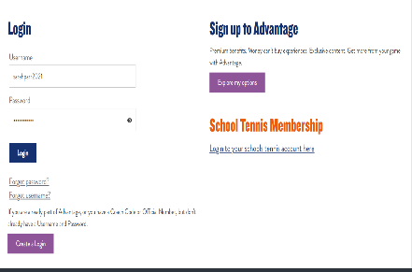

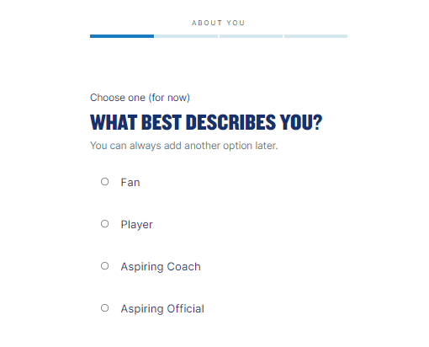

Choose: Player



