RTA JUNIOR COACHING NEWSLETTER – SUMMER 2021

Well done to all our juniors who attended our traditional junior week and congratulations to those who made finals day.
My thanks go out to my team of coaches for their hard work in supporting the event, the junior captains Rhys, Dan and Ellie were exceptional and helped enormously through the week. My thanks also go out to Alison, Michele, and Sarah for running things well off the court.

We plan to host an awards evening at the start of the new term with a social function of some sort.

Over the summer term as Head Coach, I delivered six LTA Youth Start courses at the club where we opened our club for non-members and kids were allowed to sign up and sample a 6-week term of tennis coaching. Since these successful schemes the club has attracted new junior members to the club.

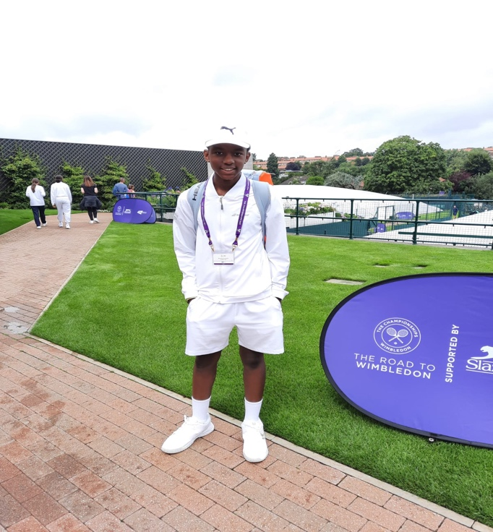

We are delighted to announce that our very own junior player Takunda won our Club Road to Wimbledon event in May, and he then went onto win the county finals, his amazing run then took him to Wimbledon where he had an amazing experience with coaching off Tim Henman and more matches.

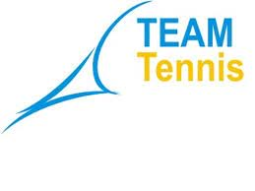
We had an excellent summer of junior team tennis which saw us enter the most teams in Wales, with 11 teams of boys and girls of mixed divisions with 5 teams winning league titles, my thanks go out to all Parent Captains and all the players who stepped in to play their part in trying to help Radyr achieve further successes.

We have had an excellent response for our 5-week programme of junior summer camps, both with members but more importantly with non-members who have since joined as members of our club. There are still some spaces for the morning sessions for u10’s and over 10’s in the afternoons.

Feedback is important so please always feel you can call or email me as Head Coach with anything that you are concerned with. I would hope you would all contact me as your first port of call. I am not someone who likes whispering of unhappy gossip so please get into touch and let me try and help solve any possible issues.

The recent Glamorgan Open 17 tournament at the club was a popular event for both members and guests from as far as Kent and the midlands. Our sponsor Halo hydration offered gifts and free samples to all players who entered.

Well done to all our competing junior players who have been busy fighting hard for wins at local, regional, and national LTA grade 5, 4, 3 and grade 2 tournaments all over the UK.
Maddie Green has been awarded a place on the LTA National pathway where she is the only girl from Wales in her age group to have achieved this.

What is a Tennis Leader?
A Tennis Leader is someone that can support the coach and/or committee with the day to day running of the tennis venue and tennis programme. Tennis Leaders is an exciting programme which can help young people develop their employability and life skills, and for those that want it, their first step on the ladder to a career in sport.
Becoming a Tennis Leader, The Tennis Leaders course is available to anyone aged 13-16yrs, plus anyone 16yrs+ in full time education, or an adult wishing to get involved. Tennis Leaders is made up of one 3-hour core module, with four additional 2-hour modules:
As HC I will be hosting a tennis leaders’ course in the coming weeks, if you would like to register your interest with an email to me with your child’s name then please do Headcoachfirstballin@gmail.com
There will be a charge of £20 per person paid to HC Phil on the day.

The September junior coaching programme will be able to book online via clubspark by the end of this week. The programme will commence on Monday 6th September and run for a 6-week term until Saturday 23rd October, there will be a week’s break in the group coaching schedule from Monday 4th October until Saturday 9th October, we will resume on Monday 11th October for the final two weeks of that term.
The RTA junior programme has always embraced the LTA pathway of player development and with its new LTA Youth programme we are excited about the new term ahead. As HC it is my objective to offer a balanced coaching and competition programme based around age and stage of development for all our junior players.
As a team of coaches, we champion tennis for all ages and a continued push for the development of grassroots tennis is vital for our club programmes. As always, we continue to embrace all ages and abilities and the sessions cannot always be staffed by me as Head Coach. I have a good team of Pro’s who all give a positive experience to each child whilst embracing our ethos of ENJOY - DEVELOP - COMPETE.

All our sessions will have a mix of fun energised warm-ups, several hand-eye-skilled exercises, as well as closed basket drills to teach all the basics of technique from correct grips to swing-lines and allow all children to have a feeling of repetition to master the skills needed. We will also allow the children to have fun and be creative in point-play and allow them to learn and experience the tactical game of singles and doubles on a match court, as well as learning to accept winning and losing.

Go to the website, select Coaching – then select LTA Youth and then choose the session for you based around your child’s age. All performance sessions will be under the performance tab and not LTA Youth.

All players under 8 years are to select LTA Youth Red “Club”, all players under 9 years are to select LTA Youth Orange “Club”, all players under 10 years are to select LTA Youth Green “Club”.

All other 11+ year old children can select a session offered as LTA Youth Yellow “Club”.

All sessions with “CLUB” labelled on them are sessions aimed at most of our club players from beginner to intermediate standard.
Junior futures squads are for players who play twice a week or more and are keen and committed and are the next ones up on their skill level.

Finally, we have the performance squads which are aimed at a lower percentage of junior member’s (local and non-local) who are pursuing tennis as their main sport and who play regular competition and train up 3 or 4 sessions a week with regular 1-2-1 lessons.

If anyone would like any further clarification on which group, you wish to enrol your child on then please contact me directly. If anyone would like to offer any feedback of previous terms of tennis, or if you have any queries or complaints then please contact me directly and not the committee. Please all me as HC an opportunity to help fix a problem with your child’s tennis programme.

We have many children who do many other sports which we know is healthy, so finding the right day or session time can be a challenge, with 26 junior group coaching sessions spanning over 6 days a week, I firmly believe there is something for everyone in what I have designed as a balanced tennis programme for all junior’s at Radyr LTC.

Finally, the myth of group coaching does not go away and its important each Parent needs to accept that there will always be somebody at the top end of the squad, several players in the middle level and unfortunately some players at the tail end of groups. This is the same for all our children in their classes who go to school.
To speed up your child’s tennis improvement then I would encourage you to join as a Parent member and hit with your child on a regular basis.

Players who fall between levels of LTA Youth Club and futures squads can opt to play in more external tournaments to help them learn the game of tennis on a match court.

The fastest way for improvement is for 1-2-1 lessons, this is more expensive, and we have some possible availability but not as much as everyone expects, this is on a first come first served basis and I have had a commitment with several players for almost 3-4 years now, so for me balancing or opening additional slots for new 1-2-1 slots is going to be a challenge.

I would like to wish our assistant coach Rhys Hill all the best as he heads off to university. Rhys has shown excellent maturity in his role as an assistant coach since our return to play from covid, and it’s been a pleasure to mentor him.

Dan Jewitt also heads off to university and we will also miss Dan’s contribution to helping on the junior programme and for both players playing in many junior and senior teams at the club.

On Saturday 4th September from 12noon we will be hosting a family day at the club with several events on including a Parent & Child doubles event from 12pm, just turn up and we will add you into the draw, at 1.30pm an adult mix in timed doubles tournament with a lucky dip for partners. The BBQ will be offered and the bar open for snacks and drinks. Please come and mix in and have a great time socialising at our club.

I am delighted to have been asked to Captain / Coach the U18 boys South-Wales county team. This is good recognition from Tennis Wales for my work done in three of the five camps in the national performance programme over the summer.

Further news to appear soon on the arrival of a new coach to add quality to the First Ball In team at Radyr LTC.

