Riding Mill Tennis Club

Lighting Report – Proposed Tennis Court Lighting

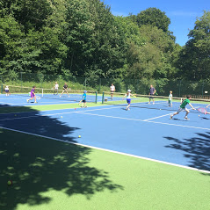

Bill Owen

I have been a lighting professional for over 40 years. Working for such organisations as Bergo Ltd, D W Windsor Ltd, Thorn Lighting plc and lately Holophane Europe Ltd.

In my career I have been involved with many aspects of exterior lighting including Decorative Floodlighting, Subway and Tunnel Lighting, Heritage Lighting Projects, Area and Car Park Lighting, Sports Lighting including Tennis Courts, 5 a Side Football Pitch Lighting and M.U.G.A. Lighting. For the past 19 years I have been Street Lighting Manager at Holophane heading up the company’s drive into lighting in the Public Realm dealing with Street, Road and Motorway Lighting throughout the UK and Ireland as well as pathway and cycleway lighting, Car Park Lighting, Sports and area lighting and other areas requiring exterior lighting.

I have regularly provided training to Local Authorities, Engineering Consultancies and Contractors on various aspects of exterior lighting including design, technology and the relevant standards and regulations appertaining to exterior lighting, throughout the UK, Eire and occasionally Europe. Provided advice and run seminars on Lighting Policy and Compliance with Dark Sky requirements and Lighting Controls.

Over many years I have given many papers to the various regions of the ILP (Institution Of Lighting Professionals - Formerly The ILE - Institution Of Lighting Engineers) and The SLL (Society Of Light & Lighting).

My practical approach to the subject, wealth of experience and technical knowledge has been built up over many decades in the lighting industry.

Introduction

Riding Mill Tennis Club is located off Millfield Road Riding Mill, Northumberland. The Club is seeking to install lighting on their tennis courts. This is to lengthen the available playing hours throughout the year and thereby encourage increased membership and improved use of the club’s facilities.
However, the club recognises the possible impact on nearby residents, and for that reason has determined that a curfew of 9:00pm will be applied by means of an electrical cut off device which will automatically switch off the supply to the lighting at 9:00pm.
Further, the installation of traditional floodlighting systems which would necessitate the use of 8-10 metres high pylons to carry the floodlights (necessary to meet the light levels and distribution of the light over the width and length of a double court playing area) would result in obtrusive light spill onto the adjacent properties as well as intruding into both the daytime and night-time appearance of the landscape.
To that end the club is proposing the use of the Tweener Tennis Court Lighting System which is mounted at 3 metres along the sides of the court (looking from the clubhouse) and is typically fixed to the top of the fencing stanchions which surround the court.

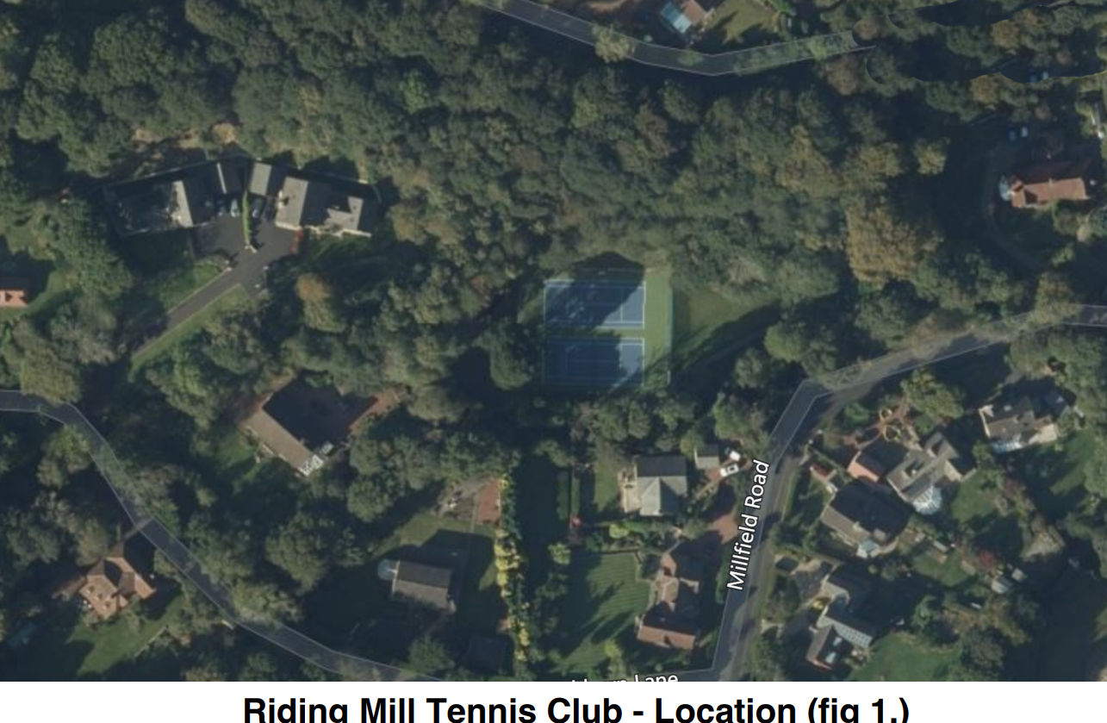

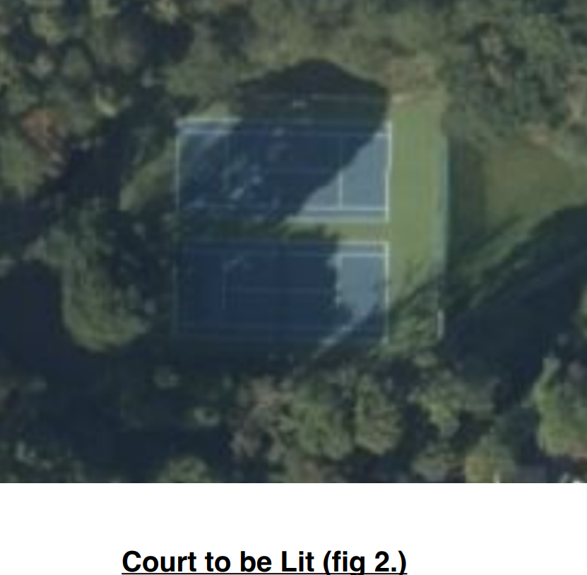

Technical Facts – Tweener System

The Tweener system uses the latest LED technology to achieve a number of aims.
1) LED’s are highly efficient at converting energy into light, typically at least 50% better than conventional discharge lighting.
2) LED lighting is highly directional and thus the light can much more controlled in respect of the direction the lighting is aimed.
3) LED’s are extremely long lived when compared to discharge lighting and thus require far less maintenance throughout the life of the installation.
4) The Tweener System uses a low mounting height of 3M which greatly reduces light pollution into the night sky, light trespass and light spill (83% of the light is aimed in a downward court focused distribution).
5) At 3M mounting height the Tweener system does not require specialist access equipment for installation and maintenance.

Proposed Installation.

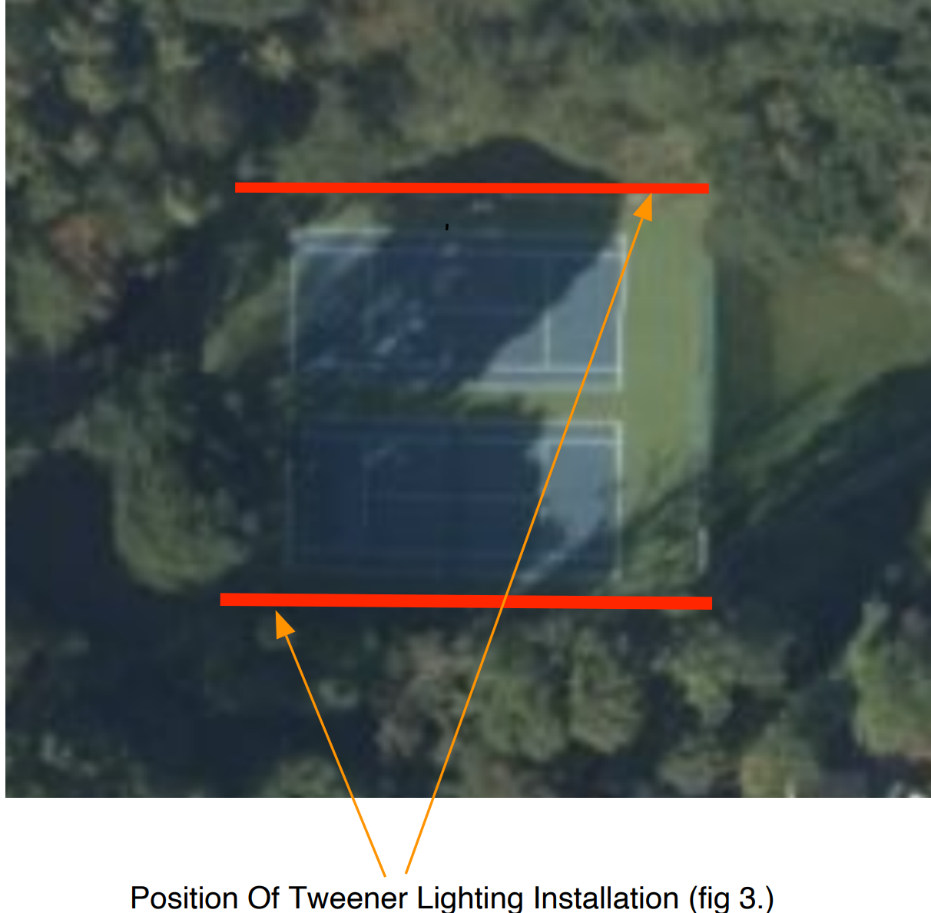

The Tweener system is designed to throw light inwards onto the court playing area from either side of the court, thus ensuring that adjacent properties are not impacted by obtrusive spill light or glare. To the left hand side (looking down the court from the Club House) Tweener is to be mounted throwing the light directly away from a heavily wooded steep bank. On the right side of the court the Tweener system will throw the light directly away from the trees and the Burn which is some meters back from the court with a verge area where the access pathway to the Club is located. Again the Tweener system will face away from the Burn and any properties across the other side of the Burn. This will obviate any light trespass or light pollution issues. It should be further noted that the Court is located in the midst of a fairly densley wooded area which would also mitigate against obtrusive Light Spill. The Ecological report undertaken by the Club shows no significant evidence of local fauna that might be affected by lighting, especially by such a system as Tweener with its low mounting height and its directional control which keeps the light contained within the playing area.

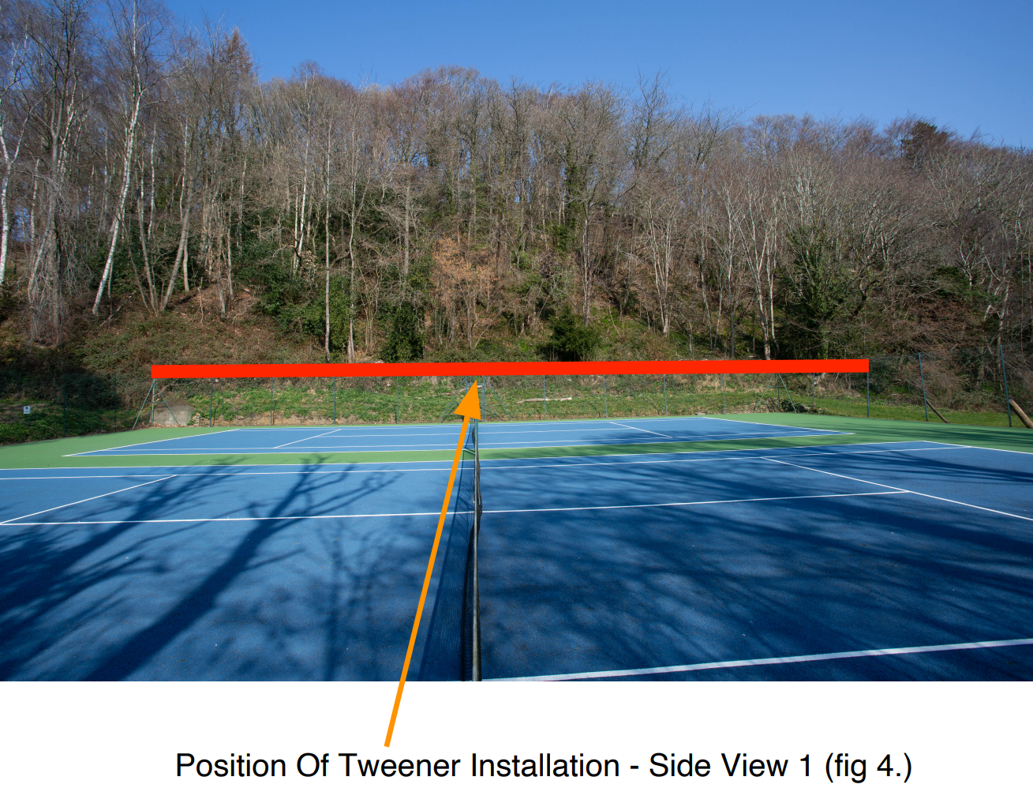

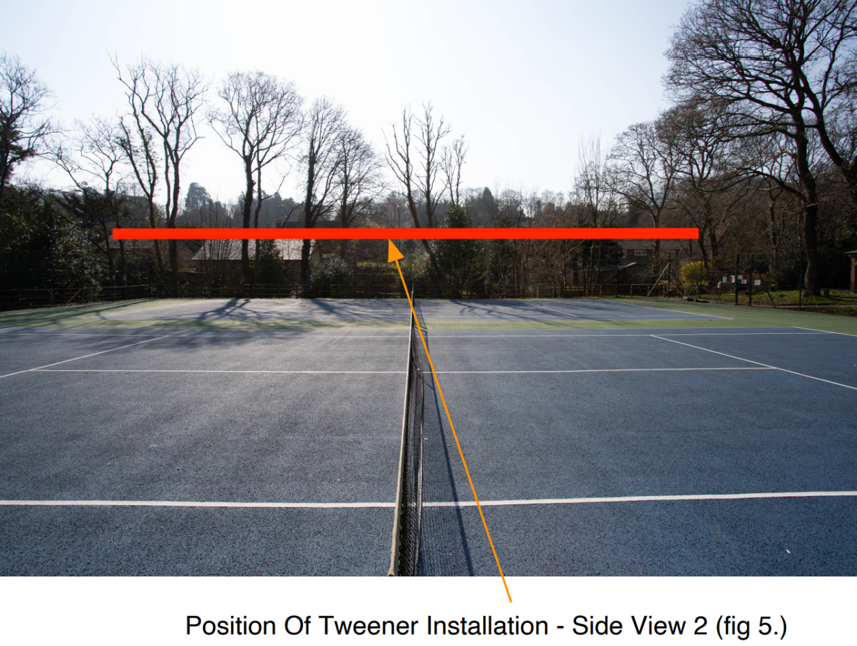

As may be seen, the Tweener System is mounted on either side of the court area running along the length of the fencing enclosing the Total Playing Area (TPA).

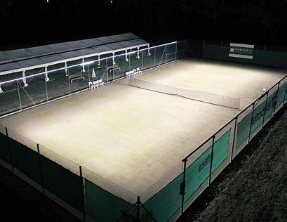

Tweener Installation (fig 6.)

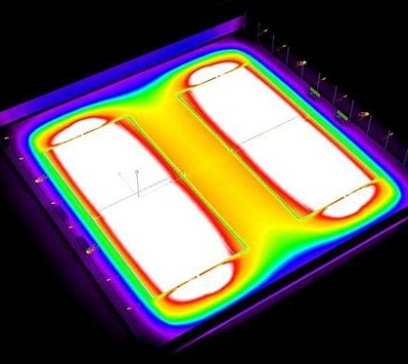

Tweener Light Distrbution (fig 7.)

The Tweener System aims the LED’s such that the light distribution is entirely contained within the confines of the court.

This creates an environment that prevents light spill into areas of neighbouring properties and negates any detrimental effect to local flora and fauna. There are no LED’s at either end of the court.

Due to the low mounting height of the Tweener System (3M) there is no obtrusive impact in the daytime or night-time appearance of the landscape.

However, with traditional pylon mounted floodlighting schemes, they can often be highly obtrusive into the day and night-time landscape (See below)

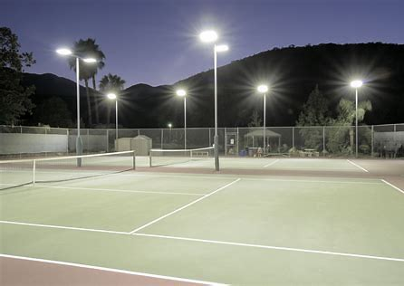

Traditional Pylon Mounted Floodlighting (fig 8.)

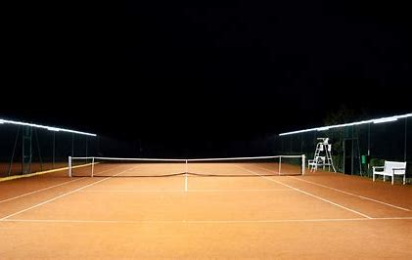

Tweener Tennis Court Lighting System (fig 9.)

Conclusion

Thus, it may be seen that the Tweener System if installed at Riding Mill Tennis Club would have minimal impact on the neighbouring residents and upon local flora and fauna. There would be some low-level upward sky glow created by light reflecting off the surface of the court, but this would be no more than that created by local street lighting and the curfew of 9.00pm would obviate any effect beyond that time.

I would recommend the Tweener system as an extremely Eco-Friendly solution to lighting the double court at Riding Mill Tennis Club.

Bill Owen
March 2022

