Thame Tennis Club Handbook
v. 03/2019

Website: Thame Tennis Club

Twitter: @thametennisclub

Facebook: https://www.facebook.com/ThameTC

Email: membership@thametennisclub.co.uk
Table of Contents
___________________________________________

Welcome from The Chairman 3

Facilities at Thame Tennis Club 4

Membership Categories 5

Benefits of Membership 6

Weekly Club Sessions 7

Court Booking and Members inviting guests 8

Coaching 9

Teams, Leagues, Club Competitions & Singles ladder 11

Social Events & The Clubhouse 13

Code of Conduct 14

Safeguarding, Welfare & GDPR compliance 16

Committee / Contact 17

Find Us 18

Welcome from the Chairman

Welcome to our tennis club!

At Thame Tennis Club we are proud to cater for all types of players through our social, competitive and coaching programmes. Whether you are a total beginner or an experienced match player, we always encourage more ladies, juniors and men to join.

The club is managed by a small group of volunteers who make sure the club runs smoothly; is financially sound; is responsible and fair to all its members in accordance with LTA guidelines; is welcoming to both members, their visitors and the local community as a whole; and to ensure that the club’s facilities are maintained on behalf of the members.

As a result, we have some of the best courts in Oxfordshire, a thriving and growing membership and a great mix of social players, match players and a successful local tennis community including non-members who either use our facilities on a PAYG basis, as a guest of a member or through coaching with our Head Coach Mark Wilkins’s extensive year-round coaching program.

All our memberships and court bookings, also for non-members, are made via our website using a system called ClubSpark. Please remember to always keep your Clubspark profile and details up-to-date, that you are registered with the LTA and that you affiliate yourself with Thame Tennis Club. If you try to make a booking with different email address, for example, it won’t work. Also, please make sure you annually opt in for Wimbledon tickets on the LTA website – you should receive annual reminders to do so. The more members we have who opt in, the more tickets our club is allocated for our annual draw.

We are always looking at ways to improve our club and the experience for members. Please feel free to contact me at any time with any ideas and if you can spare a little of your time to volunteer for the club as we are always looking for people to help out. A list of volunteer positions required is maintained on our website and updated in the “Tennis Hut”

We do try to keep members up to date with events at the club. The main source of this information is through our email service although sometimes we will also communicate through our Facebook, Instagram or Twitter pages. We also look to keep you up-to-date through posters in the Tennis Hut.

This year should, at long last, see the main clubhouse knocked down and rebuilt. All news relating to this will also be emailed and posted in the Tennis Hut behind court 4.

This handbook will give you an overview of the club. I hope you find it useful?

Many thanks

Daniel Morris
Thame Tennis Club Chairman
07970 146269 / daniel.morris16@btinternet.com

Facilities at Thame Tennis Club

Thame Tennis Club’s facilities are available to anyone who might be interested in tennis in both Thame and the surrounding villages.

The club is open to both members and non-members, the latter who can use the club’s facilities through our Pay as you Go facility, with all bookings made through our website. We also allow members to invite visitors to Thame to join them on court for a small fee.

Situated in Chiltern Grove off Queens Road in Thame, the club exists alongside Thame Bowls Club, both of which were formed in 1924.

Both the Tennis and Bowls clubs use the facilities of the central clubhouse which is owned and managed by Thame Sports Club Ltd, a Club owned by the members of both clubs.

We have a total of 6 all weather courts, 4 of which are artificial clay and the other two being macadam hard courts. We also have floodlighting covering all 6 courts, allowing for play year-round from 08:00 to 21:30 in the week and 08:00 to19:00 at the weekends if and when the floodlights are required. We do not charge members extra for the use of the floodlights.

Chiltern Grove is a private road where members and visitors can park, and we have bike-racks for your use within the club. Thame Sports Club are responsible for the maintenance and upkeep of this road, to which Chiltern Grove residents have access rights.

The Tennis club has a “Tennis hut” and a “viewers hut” opposite courts 4 and 6 respectively. These are available to all members and their visitors, to parents of children playing or in coaching programmes, especially in the cold winter months! We are constantly looking to improve the facilities in both huts.

Our website: https://clubspark.lta.org.uk/ThameTennisClub has all of the latest information for both the club and coaching.

For more information regarding Thame Sports Club please contact Peter Bozier, a tennis club member and Chairperson of The Sports Club

Membership Categories

Thame Tennis Club offer a number of types of Membership categories to look to suit all member’s needs. As of March 2019, the membership years run from when a member joins the club or when their membership is up for renewal, with membership rates changing on 1st January each year.

Adult Membership - Full single adult membership.

Couples Membership - Full adult membership for 2 persons.

Family Membership (1 Adult) - A single full adult membership with unlimited children/juniors up to the age of 18.

Family Membership (2 Adults) - Two full adult memberships with unlimited children/juniors up the age of 18.

Child Membership of a Playing Parent - child (9&Under) membership of a full paying adult member parent.

Child of Non Playing Parent - child (9&Under) membership without a paying adult.

Junior of Playing Parent - Junior (aged 10-18) membership with a full paying adult membership.

Junior of Non Playing Parent - Junior (aged 10-18) membership without a paying adult.

Student (Full Time Education) - Membership for students that are still in full time education (includes university).

Young Adult (Under 25, out of education) - adult under 25 that is no longer in education.

Benefits of Membership

---------

From £5 a week for adult membership there are many benefits of becoming a member at TTC.

All memberships include:

- Free court booking across all 6 courts

- Free court lighting across all 6 courts

- Coaching discount

- Entry into the annual Wimbledon Ballot [subject to members opting in and correct LTA ClubSpark registration]

- Use of all clubhouse facilities

- Entry in to the year-round singles ladder and inter club competitions

- The opportunity to represent TTC in county club competitions

- Unlimited access to all club sessions

Weekly Club Sessions

Thame Tennis Club runs a comprehensive social calendar of tennis that runs all year. Courts are allocated for these sessions, so play is guaranteed during these times:

Monday: Ladies Practice - 18:00 - 21:30
practice for ladies in teams or those aspiring to represent the club. The session is run by team members with a coaching session on the first Monday of the month from 19:30-21:30

Tuesday Club Night - 18:30-21:30
Social doubles mix in session for all members. Three courts are allocated through the winter with 4 allocated during the summer season.

Wednesday Midweek Club Morning 09:30-12:30
A midweek club social session of mixed doubles. Running year-round across two courts (depending on numbers) the session is open to all and is led by members.

Wednesday Mens Practice - 18:30-21:30
Practice for men that represent the club in the Oxfordshire or Aylesbury leagues through the summer or winter along with those that wish to join teams. Following the tennis there is normally a drink at the Six Bells!

Thursday Club Night - 18:30-21:30
Social doubles mix in session for all members. Three courts are allocated through the winter with 4 allocated during the summer season.

Saturday Club Morning - 10:00-13:00
Social mixed doubles with 5 courts allocated all year. Our most popular session catering to a wide variety of abilities and experience meaning the session is suitable for everyone! Arranged by Robin Wilcox, new balls are provided along with partners being arranged. There is a fee of £3.

Court Booking & Members inviting Guests
___________________________________________

Since 2017 we have successfully been running a court booking system via ClubSpark – click on this link to access the online booking system. . This has also enabled us to open our courts to the wider community through the introduction of Pay & Play Tennis on courts 1 & 2. This has increased our court utilisation, increased our revenue which in turn leads to increased participation and members.

Booking Conditions:

- Court Bookings have priority
- You can book up to 14 days in advance
- You can book a maximum of 2.5 hours in a single session
- You can book a maximum of 4 times in 7 days
- The court becomes available if not being used after 15minutes
- Please cancel any bookings that will not be used to open the court time for others

Please remember

- You will not be able to book courts through our Clubspark system if your Membership profile is not correct or up to date.
- Members who have booked courts have priority over members who haven’t booked and just turn up looking to play. Being a member does not guarantee you can just turn up and play so please always look to book first and potentially save yourself a wasted trip to the club!!
- That courts 1 & 2 can be booked by non-members by the hour for £7 [without floodlights] and £10 [with lighting]. Non-members who have paid and booked for a court have priority over members during these times.

To book a court please click here: toplay.at/Thame

Members can also invite friends or family to join them as their guests without them having to join the club. This facility is designed to enable members to invite infrequent players to play. Members are reminded that their guests need to pay £5.00 per session to the club and that guests can only play a maximum of three times in any 12-month period. The club will confirm in due course how such fees need to be paid.

Coaching
___________________________________________

Run by our Level 3 Head Coach, Mark Wilkins, coaching runs throughout the year and the courts are booked for these sessions. There are many elements that make up the programme:

Weekly Junior Programme Running during the school term we deliver over 17 junior group sessions through the week catering for all ages and abilities. We start with Tots Tennis up to U18 performance.

Weekly Adult Programme Also running in line with the school term we have Cardio Tennis, Adult improvers and Tennis Xpress.

Monthly tournaments We run tournaments against surrounding clubs on a monthly basis for a variety of age groups. These serve as a good introduction to competition and allow play against different players aside from those at Thame.

Tennis Leaders Courses Thame have a commitment to improving juniors in all areas, this includes helping players assist in the programme. tennis Leaders serves as the first step to coaching, initially enabling participants to assist with the programme. This is a formal qualification that can be used to progress the coaching ladder.

Schools Programme As part of the coaching outreach we deliver taster sessions to all Thame primary schools along with providing curriculum time coaching.

Tennis For Kids As part of the successful Davis Cup Legacy Thame deliver the 6 week course. All courses we have run have filled in days providing a fun introduction to tennis.

Holiday Camps Running at Easter, May Half Term and through the 6 weeks of summer the holiday camps see hundreds join us throughout the year. Check the website for the latest dates/times/prices. All ages and abilities are welcome!

Doubles Clinics A new introduction to the programme the clinics will be running every other month. This is a 3hr session that focusses not only on technique but doubles positioning and strategy also.

Open Days As introduction to the club we run a variety of Open days, including the LTA’s Great British Tennis Weekend.

Coaching Team:

Mark Wilkins Level 3 Club Head Coach
Stuart Lindsay Level 2
George Worthington Level 2
Matthew Shaw Level 2
Charlie Marson-Smith Level 1
Will Bruce-Morgan Level 1

For all coaching enquiries please contact the Head Coach.

HEAD COACH: markjwilkins@aol.com

Coaching Information: https://clubspark.lta.org.uk/growtennis

Teams, Leagues, Club Competitions & Singles ladder
___________________________________________

Thame Tennis Club runs a number of Ladies, Mens and Mixed teams throughout both the summer and winter seasons. Due to our location we compete in both the Oxfordshire and Aylesbury & District Tennis leagues [ADTL]. Comprising of teams of 4, 2 doubles matches take place with differing scoring for the summer and winter. Traditionally, Oxfordshire matches start at 1pm, whilst ADTL matches take place midweek or on Sunday mornings.

We also have a singes ladder for all those who want regular “competitive” singles matches against fellow members. The singles ladders run for 2-month periods and are organised by Zoe Smith. For anyone looking to join the singles ladder please email Zoe directly on zobes@btopenworld.com.

In addition, the club arranges adult friendly matches against other local clubs. These are great for those members who don’t play competitively in the County league teams but who enjoy a little friendly competition! We also encourage new members to join these matches.

Finally, the club runs our own “Club Championships”. These currently run from April up to our “Finals Day” in mid-July [weather permitting!]. We encourage all members to enter and normally have over 50 members joining these competitions specifically Mens and Women’s Singles and Doubles. Each round has a completion date [or else matches are decided by a toss of the coin!] and all finals played on the same day, hopefully in good weather and to an impressed audience?

Our “Competitions Team” also organise a number of Mixed Doubles competitions where members are paired with other members by drawing lots. This includes the “Steve Nannery Trophy” our official Mixed Doubles Tournament now played in memory of a long-term member of the club; The Chairman’s Cup, now to be organised as a “friendly” with other local clubs and The Pomeroy Cup. Other events seen in previous years include “Tipsy Tennis”, often run between Christmas and New year! Dates of these events change each year and are emailed to all members and updated on the club calendar.

The club is also indebted to Anna Roubo, Ruth Tupper and Louise James who together organise these club competitions. Details of the various competitions are emailed to members through our regular emails and posted in the tennis hut, behind court 4.

At the time of writing the current Thame Tennis Club captains in the various County Leagues are as follows:

Ladies 1 Winter ADTL Dawn Munro
Ladies 2 Winter ADTL Rosie Collins
Ladies A Winter Oxfordshire Anna Roubo
Ladies A Summer Oxfordshire Jenny McLeod
Ladies B Summer Oxfordshire Anna Roubo
Ladies 1 Summer ADTL Maria Lawton
Ladies 2 Summer ADTL Rosie Collins
Ladies 3 Summer ADTL Helen Frost

Mens A Winter Oxfordshire Alex Brown
Mens B Winter Oxfordshire Richard Bradley
Mens 1 Winter ADTL Nigel King
Mens A Summer Oxfordshire Alex Brown
Mens B Summer Oxfordshire Richard Bradley
Mens C Summer Oxfordshire Simon Halls

Mixed 1 Winter ADTL Nikki Jackson
Mixed A Summer Oxfordshire Dawn Munro
Mixed B Summer Oxfordshire Ruth Tupper
Mixed 1 Summer ADTL Nikki Jackson

The club is particularly indebted to Dawn Munro, our fixtures secretary, who has the unenviable task of organising all of these matches with all the other clubs!

Thank you also to all of the above captains for their time in organising their respective teams, not always an easy task!

If you are interested in playing in any of these teams [competitive or friendly] please email Head Coach Mark on markjwilkins@aol.com

Social Events / The Clubhouse
___________________________________________

In addition to the various social tennis activities the club has, in the last 15 years or so, been an active social hub for members. We have seen Black-tie dinner and dance evenings and more recently annual general knowledge and wine quizzes.

As well as being an important source of funds for our club [about the equivalent of 8 full time memberships] we, as members, seem to enjoy each other’s company both on and off the court! The club is indebted to Willemien and Graham Barnes, Helen and Julian Frost, Nicky McRobert and myself, for their efforts in organising the annual quizzes over the last 5 years. This “Social Team” have hung up their rackets and need replacing.

If any club member has some free time and ideas to keep these social activities going, in the same or different formats can you please contact me?

Please also note that the main clubhouse is available all year round as a social venue for club members. The clubhouse can be booked by members for personal events and if requested the bar can be opened by one of the “trained” bar personnel. Pete Bozier and John Ansell, from the tennis club are two such trained bartenders and there are others from Thame Bowls Club.

The Tennis Club use the clubhouse for “post-match teas”, our Annual forum / AGM [normally hosted in about October], committee meetings and, for example, the Wimbledon Draw, normally held in the first or second week of May.

The clubhouse itself, is due to be knocked down and rebuilt. It is hoped that this work will begin in September 2019 and should take about 6 – 7 months to complete [timing to coincide with The Bowls Club winter season]. As soon as this is finally confirmed an email will be sent to all members, including the implications on the Tennis Club and our facilities during this period.

Code of Conduct

Thame Tennis Club aims to provide a tennis venue that is safe, inclusive and has a positive atmosphere so that everyone is able to enjoy playing tennis at this Club.

Our code of conduct is designed to support this aim. So, we expect everyone to respect and include all members, visitors and spectators regardless of:
  - age
  - gender
  - sexual orientation
  - race
  - nationality
  - ethnic origin
  - religion or belief
  - ability or disability

The standards we expect are:
- That all Members are paid up and renew their membership at the given time
- That we all encourage fair and safe play at all times
- That all members respect the Club’s Code of Conduct and the guidelines of this Handbook at all times
- To respect the actions and decisions of the volunteers who run our club
- To not permit offensive, abusive or intimidating language or behaviour
- To discourage disputes over calls
- To wear suitable attire including trainers
- To wait until a suitable break in play to walk behind, enter or leave the courts
- To sweep courts 3, 4, 5 & 6 after use and brush all lines so that the courts are immediately playable for the next players [only applies in dry conditions]
- To clear any debris from the courts before playing
- To leave the courts and facilities as we would hope to find them
- To ensure that doors to the clubhouse and facilities are locked before we leave
- To switch mobile phones to silent on or around the courts
- To talk quietly when play is in progress
- To follow the agreed process for court bookings and for playing guests
- To always respect the Chiltern Grove residents, keeping noise to a minimum, especially after 20:00

Finally any concerns should be raised directly with a member of the committee and not through gossip or negative behaviour with other members

Anyone found to be persistently breaching the code of conduct may be subject to the club’s Disciplinary Procedure.

Disciplinary Procedure

Disciplinary matters, applying to all matters of Thame Tennis Club will be dealt with by the club Committee. All members of the Club agree to fully comply with this code of conduct.

Disciplinary action against Club members, including expulsion without notice, may be taken for offences of misconduct or breach of club’s rules. However, it is recognised and accepted that every member: -

- Has the right to expect fair and consistent treatment
- Has the right to adequate notice from the Club
- Has the right to representation
- Has the right to appeal against the Committee’s decision in all disciplinary matters.

Appeals are held by the club Chairman, treasurer and a representative of the club member [unless any of the above are directly involved in the dispute when a substitute will be found]

The decision of the Appeal hearing is final and binding on the parties and not subject to further appeal.

We are a small and friendly club and hope to never have to consider such issues with any member in this way but such guidelines are needed in the best interest of all members.

Safeguarding, Welfare & GDPR compliance

Our club is here to offer a safe and inclusive environment for everyone to enjoy tennis and we follow the precise guidelines as laid down by our governing body, the LTA.

We are all responsible for ensuring we act appropriately at the club and in line with our safeguarding policy which can be found both on our website or in the tennis hut, please do familiarise yourself with this so we can ensure that a safe game can be had by all. To view the policies please click on this link

Thame Tennis Club’s welfare officer is Zoe Smith who can be contacted on 07590042209 or via email at zobes@btopenworld.com should you have any concerns about yourself or anyone else at our club. Zoe is also an active member of the committee and is trained and registered to ensure the clubs safeguarding policies are up to date and we all act accordingly. Please remember that, in line with our safeguarding policy doing nothing is NOT an option so if you see something of concern please do report it.

Thame Tennis Club is GDPR compliant.

Our Data Protection manager is John Patrick. John can be contacted via email on TTC.DPM@DosCucharas.uk. The Thame Tennis Club privacy policy sets out the way we process your personal data and we’ve created this privacy policy to make sure you are aware of how we use your data as a club member or PAYG guest. To view our data protection policies please click on this link

Our thanks to both Zoe and John for ensuring the club maintains the required standards at all times.

Committee / Contact Details

The following members currently volunteer as your club’s Committee:

Name | Role | Contact
Daniel Morris | Chairman | Daniel.morris16@btinternet.com
Ann Green | Treasurer & Tennis Club representative on the Sports Club | ann.green54@btinternet.com
Peter Bozier | Sports Club Chairman | peterbozier@hotmail.co.uk
Dawn Munro | Fixtures Secretary | dmunro2011@hotmail.co.uk
Zoe Smith | Safeguarding Officer | zobes@btopenworld.com
Nicky McRobert | Joint Secretary | nickymcrobert@gmail.com
Helen Frost | Joint Secretary | the4frosts@btinternet.com
John Patrick | Data Protection Manager | TTC.DPM@DosCucharas.uk
Mark Wilkins | Head Coach | markjwilkins@aol.com

The following members also volunteer for the club – and we need more!!

Name | Role
Andy Kaminski | Groundsman
Richard Bradley | Court Maintenance
Ruth Tupper | Competitions Team
Louise James | Competitions Team
Anna Roubo | Competitions Team

To enquire about volunteering for the club, especially to help in the marketing of the club and to relaunch our social activities please contact me – details below

Many thanks

Daniel
daniel.morris16@btinternet.com / 07970 146269

Our Location

Thame Tennis Club [click on this link for google maps]

Chiltern Grove, Queens Road, Thame, Oxfordshire, OX9 3NH

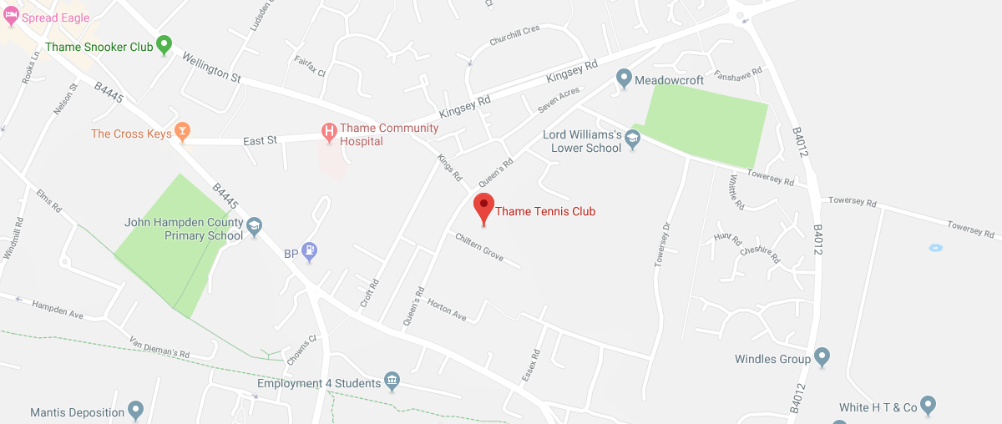
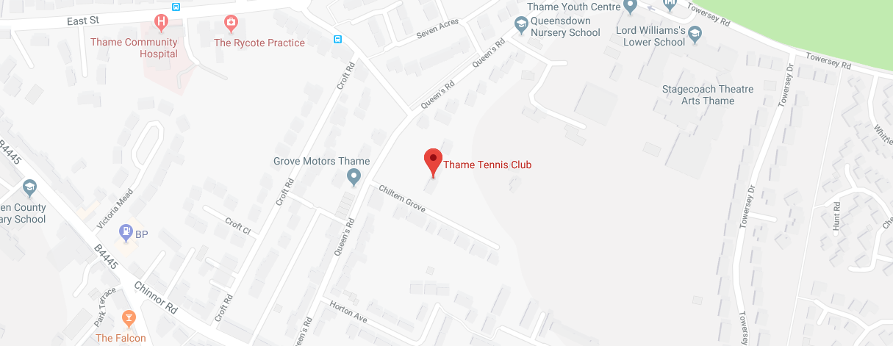

clubspark.lta.org.uk/thametennisclub

